Student Name
Group | Sem 5 – DCRM (January 2026)

Practical 5 – SQL

A library manages book records and borrowing details using a spreadsheet. This makes it difficult to track available books, borrowed books and borrower details. Therefore, you are assigned to design a database to manage book borrowing information, so the library can operate in an organized, efficient manner.

Below is the Entity-Relationship Diagram (ERD) for the library system.

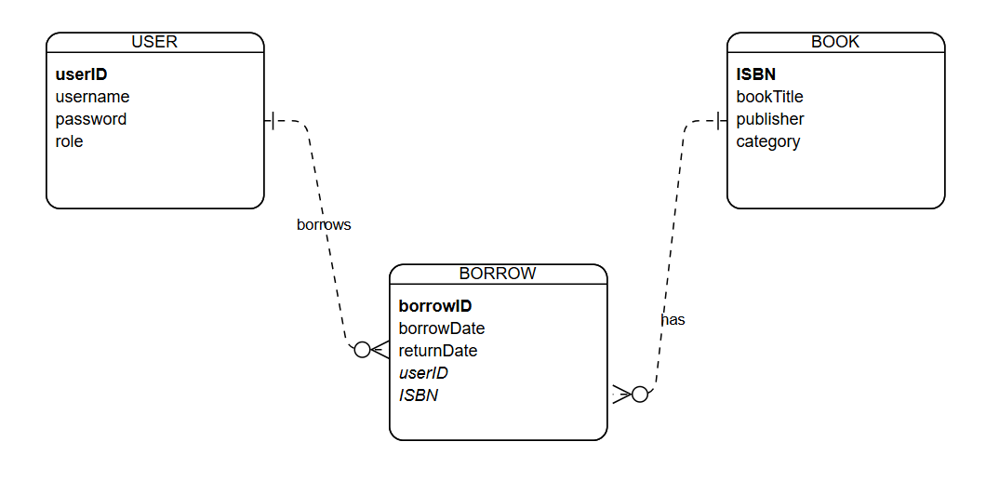

The data dictionary for each table:

Table: USER
Attribute name | Data type | Remark
userID | char(5) | Primary key
username | varchar(50)
password | varchar(50)
role | varchar(50) | Role: user, admin

Table: BOOK
Attribute name | Data type | Remark
ISBN | char(10) | Primary key
bookTitle | varchar(50)
publisher | varchar(50) | Example: Wiley, Pustaka Aman,
category | varchar(50) | Category: Academic, Novel, Fiction, Magazine, Technology

Table: BORROW
Attribute name | Data type | Remark
borrowID | int | Primary key  Auto-increment
borrowDate | date
returnDate | date | returnDate must be after borrowDate
userID | char(5) | Foreign key  References to table USER
ISBN | char(10) | Foreign key  References to table BOOK

- Create those tables in the MySQL database using phpMyAdmin.

- Insert sample data into those created tables. (at least 5 data)

- Write the SQL statements to do the following:

  - Display all the books' information.
SELECT *
FROM book;

  - Display all the users’ information.
SELECT *
FROM user

  - List all the book titles and publishers for all the books under the category “Fiction”.
SELECT bookTitle, publishers
FROM book
WHERE category = “Fiction”;

  - Find how many books for each category.
SELECT category, COUNT(*) AS total_books
FROM book
GROUP BY category;

  - List all the users’ names, book titles, and borrow dates who borrowed the books in the month of March 2026.
SELECT u.username, b.bookTitle, w.borrowDate
FROM user u, book b, borrow w
WHERE u.userID = w.userID
AND b.ISBN = w.ISBN
AND month(w.borrowDate) = 3
AND year(w.borrowDate) = 2026;

  - Update the publisher name to “TechBook” for all the books under the category “Technology”.
UPDATE BOOK
SET publisher = ‘TechBook’
WHERE category = ‘Technology’;

  - List all the book’s information and user’s information who borrowed the books title “Database Management”

Select b.*, u.*
From book b, user u, borrow w
Where b.isbn = w.isbn
And u.userID = w.useID
And b.bookTitle = ‘Database Management’

